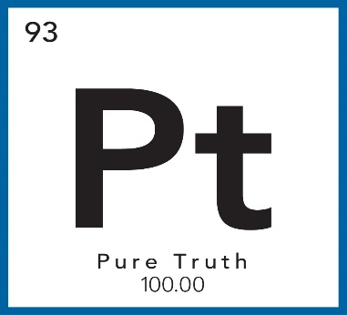

**Pure Truth Scholarship**

**Letter of Recommendation**

As one of the Pure Truth Scholarship applicant’s references, please compose a letter of recommendation for the applicant, giving any information you deem important to share concerning the applicant and their pursuit of success. **Please specifically include how you have seen the applicant be a positive change agent for their peers**.

The letter may be electronically sent to Sandra Campbell, Pure Truth Director at [sandra@thepuretruth.net](mailto:sandra@thepuretruth.net) or mailed to Pure Truth Scholarship Program, c/o Grace House Ministries, 919 E. Eureka, Weatherford, TX 76086. Deadline for scholarship applications is 4:00 p.m. Thursday March 20th, 2025.

Thank you very much for your investment in the lives of students and their pursuit of success.

Pure Truth Scholarship Committee

Grace House Ministries